

**Department of Mechanical Engineering**

**MECH 486a – Senior Design**

**Melt Extrusion Additive Manufacturing Filament Drive**

Submitted by:

|  |  |  |
| --- | --- | --- |
| Jacob Miller –  Project Coordinator |  | ID: 833030997 Jacob.Miller@colostate.edu |
| Xander Curry –  Purchasing & Data Analyst |  | ID: 833174700  Alexander.Curry@colostate.edu |
| Brenner Craft –  CAD Product Designer |  | ID: 833004439 Brenner.Craft@colostate.edu |
| Sam Smith –  Controls System Engineer |  | ID: 835338631  Samuel.Hudson.Smith@colostate.edu |

**Sponsor**

Manufacturing Technology Deployment Group, Inc. (MTDG)

**Advisor**

Dr. David Prawel

**TA**

Sami Ahmmed Khatib

**Professors**

Primary Instructor - Mitchell Stansloski, PhD

Instructor - PE Wade Troxell, Ph.D.

May 6th, 2025

# Table of Contents

Table of Contents 2

Table of Tables 4

Table of Figures 4

Introduction 5

Problem Statement 6

Background 6

Environmental Impacts 6

Existing Solutions 6

Proposed Project 7

Quality Function Deployment 7

Customer Requirements 8

Performance Specifications 8

Precision (Constraint): 9

Easy Assembly (Objective): 9

Fast Response Time (Constraint): 9

Small Footprint (Objective): 9

Lightweight (Constraint): 9

Maximize Lifespan (Objective): 10

Proposed Solution 10

Concept Generation and Evaluation 10

Comprehensive Design 12

Design Factors 14

Design for Additive Manufacturing: 14

Design for Assembly: 14

Design for Precision: 15

Design for Safety 15

Tradeoffs 15

Risk Analysis and Mitigation 16

Associated Risks 16

User Risks 17

Design Risks 17

Design Evaluation 18

Predicted Performance 18

Precision 19

Easy Assembly 20

Fast Response Time 20

Small Footprint 21

Lightweight 21

Maximize Lifespan 21

Probability of Success 22

Precision 22

Easy Assembly 23

Fast Response Time 23

Small Footprint 24

Lightweight 25

Maximize Lifespan 25

Results & Test Procedure 26

Objective 26

Environment 26

Test Steps 27

Expected Results 27

Actual Results 28

Pass/ Fail Criteria 28

Comments 29

Future Work 29

Project Plan 29

Schedule 29

Budget 31

Conclusion 32

Appendix A: House of Quality 33

Appendix B: Gantt Chart 34

Appendix C: Design Matrices 36

Appendix D: Initial Design Ideas 37

Appendix E: Initial Proof of Concept CAD 38

Appendix F: Final Prototype CAD Models 40

Sources 45

# Table of Tables

Table 1: Customer Requirements 8

Table 2: Pressure Actuation Design Matrix 10

Table 3: System Morphology Chart 10

Table 4: Design Tradeoffs 14

Table 5: FMEA 17

Table 6: Control System Design Matrix 34

Table 7: Sensor System Design Matrix 34

Table 8: Power System Design Matrix 34

# Table of Figures

Figure 1: Diagram of Traditional Melt Extrusion Printer 7

Figure 2: Selected Design Sketches 15

Figure 3: CAD Model of Design. 16

Figure 4: Prototype Sketch 18

Figure 5: Actuation Movement 21

Figure 6: Stepper Motor & Lead Screw 21

Figure 7: Pre-Made Linear Rail [4] 21

Figure 8: Initial Cad Design 22

Figure 9: PETG Spool Diameter Readings 25

Figure 10: ISO Drawing with Dimensions 27

Figure 11: Test Bench Configuration 28

Figure 12: Static Force Test Data Figure 13: Dynamic Force Test Data 30

Figure 14: Force Distribution Comparison 30

Figure 15: Schedule 32

Figure 16: 3D Filament Drive Prototype Cost Breakdown 33

Figure 17: Current Budget Breakdown 33

Figure 18: Design 1: Servo & Linkage 39

Figure 19: Design 2: Linear Actuator 39

Figure 20: Design 3: Stepper Motor & Arm 39

Figure 21: Design 4: Stepper Motor & Lead Screw 39

Figure 22: First Prototype Isometric View 40

Figure 23: First Prototype Side View 40

Figure 24: First Prototype Top View 41

Figure 25: First Prototype Detail View 41

Figure 26: Final Prototype Front View 42

Figure 27: Final Prototype Top View 42

Figure 28:Final Prototype Isometric View 43

Figure 29: Final Prototype Front View 43

Figure 30: Final Prototype Exploded View 44

Figure 31: Pressure Arm Drawing 45

Figure 32: Mounting Bracket Drawing 45

Figure 33: Electronics Housing Drawing 1 46

Figure 34: Electronics Housing Drawing 2 46

# Introduction

In order to produce accurate parts, melt extrusion (MEX) 3D printers must have a consistent and predictable rate of extrusion. Steady extrusion rate relies on manufactured filament to be precisely consistent in cross sectional diameter. Unfortunately, manufacturing imperfections often result in minor variations to the filament size. MEX 3D printers have no way to account for variation in the filament size meaning that an inconsistent volume of material is extruded. The following image illustrates this issue.

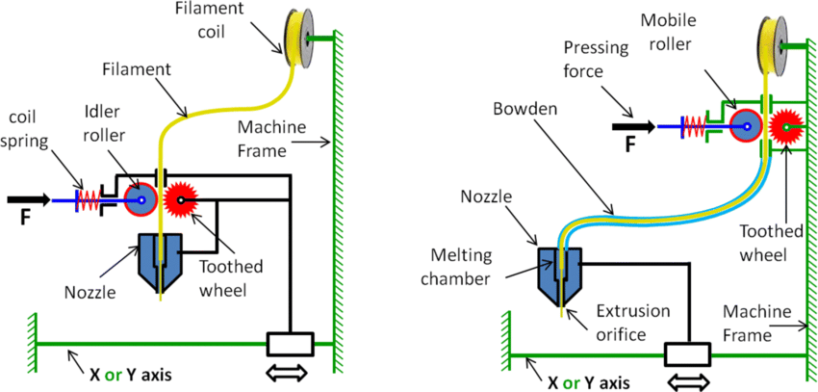

Figure 1: Diagram of Traditional Melt Extrusion Printer

[1]

The pressing force applies a constant force to the mobile roller, sandwiching the filament in between the roller and the toothed wheel. The toothed wheel rotates to feed the filament through the Bowden tube and into the nozzle. Any inconsistency in the diameter of the filament is not accounted for. Thicker than average filament can cause binding or shredding of the filament, and thinner than average filament can lead to slippage where no filament is extruded.

## Problem Statement

Inconsistent extrusion rate caused by printers being unable to account for variation in filament diameter creates excess waste prints that do not meet design specifications. This issue leads to an excess of failed prints and wasted time. The Manufacturing Technology Deployment Group (MTDG) noticed this issue and approached Dr. David Prawel, the faculty sponsor for this project, for a solution. The intended solution will need to be open source to ensure that as many MEX 3D printer users can benefit from it.

## Background

Within the realm of MEX Additive Manufacturing (AM), print quality has been a persistent issue, particularly in mid-level 3D printing systems which typically cost less than $5,000.

Fused Deposition Modeling (FDM) 3D printers in this price range often struggle with accuracy due to mechanical design flaws, one of the key contributors being the filament extrusion process. Inconsistent filament diameter can result in either excessive or insufficient material extrusion, leading to print failures. Over-extrusion can cause nozzle clogging when excess material enters the melting chamber but fails to melt quickly enough, disrupting the consistent flow needed for proper print deposition. On the other hand, under-extrusion, driven by diameter variations, results in insufficient material deposition, weakening part rigidity and compromising overall print quality. Additionally, temperature fluctuations of ±5°C further exacerbate these problems, contributing to nozzle clogs in up to 30% of prints and accounting for 15% of all failures in FDM printers [2]. This multifaceted issue not only affects the extrusion process but also leads to uneven prints that weaken part strength and introduce other defects. Addressing these challenges is crucial for improving the reliability and quality of mid-level 3D printing systems.

### Environmental Impacts

The environmental implications of these issues are significant. Failed prints often result in wasted filament, increasing the consumption of raw materials, energy, and time. Most commonly used filaments, such as PLA, while marketed as biodegradable, still take years to break down under typical environmental conditions. Additionally, the energy-intensive nature of 3D printing amplifies the carbon footprint of every failed print. Addressing these inefficiencies not only improves print quality but also reduces material waste and energy usage, making additive manufacturing a more sustainable practice.

### Existing Solutions

Several solutions have been proposed to mitigate print defects caused by filament diameter inconsistencies and other extrusion-related issues:

1. Filament Diameter Sensors: Commercially available sensors measure filament diameter in real-time and adjust extrusion parameters to compensate for fluctuations. However, these systems are often expensive and not widely adopted in mid-level 3D printers due to cost constraints. Additionally, they do not correct for extruder pressure which can result in shredding or chipping of filament.
2. High-Precision Filaments: Some manufacturers produce filaments with stricter diameter tolerances, but these materials are typically costlier and not accessible to all users.
3. Post-Processing Detection: Non-destructive evaluation methods, such as X-ray imaging, have been employed to detect defects after a print is completed. While effective, these solutions do not prevent defects during the printing process and add additional steps to the workflow.

### Proposed Project

A recent study conducted by Dr. David Prawel’s research group at Colorado State University, titled *Non-destructive Evaluation of Melt-Extruded Part Quality Using in Situ Data* [3], highlighted the direct impact of filament diameter on 3D print quality and rigidity. Using a filament diameter sensor designed by Thomas Slanderer and a custom data acquisition system developed by the researchers, the group successfully detected defects in 3D prints. Pressure testing confirmed that prints with detected defects exhibited faster pressure decay, validating the claim that filament diameter inconsistencies adversely affect print quality and rigidity.

Building on these findings, the objective of this project is to design a system capable of maintaining consistent force applied to filament regardless of filament diameter, thereby reducing final product print defects and failures.

By addressing the shortcomings of existing solutions and focusing on real-time compensation for filament diameter inconsistencies, this project presents a robust approach to improving print quality. This system not only aligns with sustainability goals by reducing material waste and energy consumption but also enhances the accessibility and reliability of mid-level FDM 3D printers. Given the proven correlation between filament diameter and print quality, our project has a high probability of success and could set a new benchmark for precision in additive manufacturing.

# Quality Function Deployment

The following section contains information related to the quality function deployment (QFD). Explanations of customer requirements and performance specifications can be found here, and a full House of Quality can be found in Appendix A.

## Customer Requirements

The target customers for this project include a wide range of melt extrusion 3D printer users. While the sponsor of this project does want the problem solved, they are not the intended end user. MTDG asked that the final product be entirely open source allowing for as many people as possible to benefit from it and theoretically enabling all melt extrusion 3D printers to be upgraded. The ability for all 3D printers to be enhanced is unlikely and unrealistic. Entry level and low-quality machines will likely have larger issues that will overshadow the correction gained from this product. Similarly, very high-end commercial printers have ways to compensate for this issue and therefore are unlikely to require it. The target customer base can be reduced down to people that use melt extrusion 3D printers in the mid-grade quality range. This customer group can be further reduced by the usage of the machines. Many consumers are satisfied with the tolerances of current 3D printers and therefore have no need for this device. Only customers that are looking for high quality, precise prints would benefit from this product.

The intended customers for this product have several critical requirements. The most important and obvious requirement is that this product needs to improve force consistency on filament. Additionally, the device needs to not negatively impact any other printer functionality in a significant manner. This means that the same print speed and volume must be achieved. By making the product as light as possible, with as small a footprint as possible, retaining previous print properties should be attainable. The last two requirements are of less importance at this time but are still under consideration in the design process. The final product needs to be easy to assemble since the final product is intended to be built by a consumer with average technical ability. Finally, the design needs to have a long lifespan. The following table provides these requirements in order of importance along with which of the customers require each specific quality.

Table 1: Customer Requirements

|  |  |  |
| --- | --- | --- |
| Customer Requirement | Relative Importance | Requiring Customer |
| Precision | 1 | End user/MTDG |
| Maintain print properties | 2 | End user |
| Open Source | 3 | MTDG/ End user |
| Low Cost | 4 | End user |
| Easy to assemble and use | 5 | End user |

## Performance Specifications

For this project the most important performance specifications were set after comparing customer requirements, sponsor expectations, and the project timeline. It was decided that in order to maximize the device’s performance while simplifying the design process the main six focused on would be to improve precision, ease of assembly, lifespan, and response time while making the device as small and lightweight as possible.

### Precision (Constraint):

In research it was found that commercial filament diameters can fluctuate between 1.65 and 1.85 mm. As the diameter of the filament changes, the passive pressure wheel will move in accordance, allowing for consistent extrusion pressure and better print quality. In terms of precision, the device is going to have to accurately apply pressure to the filament across this range of diameters with a minimum change in displacement of 0.01 mm. This would allow for every variation of filament diameter to be reached without putting excess weight on the processing.

### Easy Assembly (Objective):

This specification comes directly from the project sponsor and is one of the most important aspects of the project. The goal is to make the device out of as many 3D printed and off the shelf components as possible. This will ultimately make the eventually open-source project more intuitive at assembly if parts are designed to fit one way. Custom machined components or difficult assembly will reduce the number of users willing to implement the solution. The target value for this specification is fewer than 50 added parts. This includes all hardware and electronics.

### Fast Response Time (Constraint):

In order to make this solution appealing to users, it needs to not negatively impact current printer properties in any significant way. This includes maintaining the current print speed. Decreasing the response time to the motor actuator will require fast algorithmic processing and efficient motor drivers. Extrusion modifiers of printers can vary depending on the application but average extrusion rates for common materials are 8-12 mm/second. Therefore, the micro-processor and actuator’s maximum speed when at load must be faster than 12 mm/s to prevent print speeds from dropping.

### Small Footprint (Objective):

The objective of reducing the footprint of the device is to prevent it from inhibiting the device at all. The project must be able to be mounted as a Bowden drive system for the most common entry level melt extrusion printers. In order to do so, the overall size of the device must be small enough to not interfere with the print head and decrease the build volume. This specification also decreases the amount of material needed, decreasing the cost of production. The Ender 3 style printer has a size limitation of 150mm (this refers to the amount of space between the gantry bar and the back edge of the print bed).

### Lightweight (Constraint):

In couple with decreasing the size of the device, making it lighter will allow the device to be implemented on as many printers as possible without inhibiting print performance. If the device is lighter, it will put the least amount of stress on the printer frame and ensure that existing components do not wear out prematurely. Additionally, the lighter the device the easier it will be to implement the design as a direct drive and allow for faster speeds on the print head. On a Bowden tube style printer, the stepper motor which raise and lower the gantry bar as a lift capacity of roughly 8,000 grams. To maximize performance the device needs to weigh less than this and building in a large factor of safety and reliability, the goal will be under 1,000 grams. This will allow for the addition of the necessary electronics and actuators without drastically reducing printing speeds.

### Maximize Lifespan (Objective):

When adding components to a 3D printer it is not economical or practical to add a device requiring more maintenance than the printer itself. The device will reduce the effect of plastic shavings worsening extrusion quality, but by using durable housing materials and power efficient motor controllers the need for maintenance will decrease. When printing regularly with adequate settings, the hot end of a printer should receive cleaning, and the nozzle should be replaced about every six months. In line with this reasonable level of upkeep, this device will only need to be checked and require cleaning and maintenance roughly every six months.

# Proposed Solution

The following section details the proposed solution to this problem as well as the methods used to develop and validate the solution.

## Concept Generation and Evaluation

As there is no current solution to this problem, there is limited reference material to base a design off of. The design team used a variety of methods to develop ideas. The team mainly used a form of brain writing, where each member attempted to solve the problem individually. Solutions were based off prior engineering knowledge as well as research on similar devices used in other applications. Once each person had developed and sketched a few potential solutions, a group review session was held, and the designs were refined and modified. The top four ideas were refined, and more elaborate sketches were created.

To select a design to proceed with, a design matrix was created for each aspect of the solution, actuation, controls, measurement sensor, and power. Each team member filled out one of these charts, and the responses were averaged. The design matrix for the main pressure actuation can be seen below. The design matrices for other aspects of the design can be found in Appendix C.

Table 2: Pressure Actuation Design Matrix

The design matrices helped to select a design with the highest probability of success. A morphology chart depicting all options for the subsystems of the design can be seen in the table below. The selected design for each section is highlighted in green, and the yellow boxes denote options that were used in certain cases.

Table 3: System Morphology Chart

|  |  |  |  |  |
| --- | --- | --- | --- | --- |
| System | Option 1 | Option 2 | Option 3 | Option 4 |
| Pressure Actuation | Servo Motor & Linkage | Linear Actuator | Stepper Motor & Spring Arm | Stepper Motor & Lead Screw |
| Control System | Open Loop Control | Closed Loop Control |  |  |
| Measurement System | Hall Effects Sensor | Load Cell | Strain Gauge |  |
| Power | Stock Printer Power Supply | Upgraded Printer Power Supply | Independent Second Power Supply | Connect to 3D Printer Motherboard |

The proposed solution to this problem is comprised of four subsystems. The most important of these systems is the pressure actuation mechanism. For this reason, the majority of design time thus far has been allocated to researching and designing the control loop to provide consistent pressure. The original design sketches for the four leading ideas can be found in Appendix D of this report. The selected mechanism is a system that uses a stepper motor and lead screw to apply pressure. The stepper motor system was chosen for several reasons. One of the main benefits of this system over other proposed solutions is the adaptability to a wider range of printers. Design idea three with a pivot arm was also well liked, but the larger space requirement made it less desirable. The linear design of this system made it favorable compared to designs one and three. Another major factor that led to this system being chosen was the response time. Stepper motors have a quick enough response time to adjust to filament variation. The linear actuator design is remarkably similar in size, but research suggested a much slower response time making it unrealistic for this application. Other ideas that were not pursued included a cam and follower design and an electromagnetic system. These designs were ruled out early on as the cam design would not meet size limitations and an electromagnetic system would not be precise enough. The chosen design provides fast and accurate response while having a form that allows easy adaptability to a wide range of printers.

The other three subsystems were much easier to pick a course of action for the prototype. The control system could either be open or closed loop. A closed loop system was chosen as this option provides feedback to the system and allows for adjustments in real time. This design will adjust position based on the filament dimensions but will also have strain gauges that measure the force applied to the filament which is then fed back to the controller to fine tune the applied force. An open loop system would only adjust the pressure based on the filament measurement, but no information would be gathered on if that adjustment provided sufficient pressure.

For the measurement system, the hall effects sensor was chosen as this is a tried-and-true component that has been used by others doing similar research to this project. The students working in Dr. Prawel’s research lab used this system to gather the baseline data on filament irregularity with great success. For this reason, the hall effects sensor was chosen as the primary measurement system. A linear potentiometer will also be used as a secondary measurement system and will allow for high quality positional data that accounts for backlash. For redundancy and feedback, there are strain gauges mounted to the pressure arm that provide readings on the actual force applied to the filament. This secondary measurement allows for greater precision and verification that desired results are achieved. A load cell was used on the test setup. However, the large size made it impractical for the printer prototype, and strain gauges were chosen instead.

The final subsystem that was chosen was the power source. The design team decided that the low current draw of the designed system will be able to run off the stock printer power supply and have therefore chosen not to add a secondary power supply.

# Comprehensive Design

The selected design style for pressure actuation is shown in the figure below. The early concept sketch is shown on the left, and a revised version is shown on the right. The device receives data from the measurement system, and using the dimensions of the incoming filament, a stepper motor moves a carriage on a linear rail. Early revisions included a spring that would account for smaller variation in the filament that the stepper motor could not compensate for. The revised design removed this spring in favor of a direct method of applying pressure. This spring was removed as it may have reduced the precision of the system.

Figure 2: Selected Design Sketches

As mentioned previously, the measurement system that is used in this system is taken from an existing design. This measurement system has been tested and has proven to be functional, so no revisions were necessary. A limit switch is mounted on the bracket behind the linear rail carriage that allows the device to set a known location for reference. The system uses open position control meaning that there is no feedback from the linear potentiometer but that does not matter when looking at positional data. The strain gauges mounted to the pressure arm are inside a closed PID loop reporting the actual force applied to the filament and stepping in or out to obtain the target force. The control system is comprised of an Arduino, and a stepper motor driver that work together to control the motion. A CAD model of the final prototype with the sensors can be seen in figure 3 below.

Figure 3: CAD Model of Design.

## Design Factors

The following subsections contain the factors that were considered while creating the design. These factors were developed in correlation to the performance specifications with consideration for the final product.

### Design for Additive Manufacturing:

In order to make this project accessible to a wide range of users, and to keep part cost low, all custom components were made using additive manufacturing. This provided multiple benefits when compared to other manufacturing options. Firstly, additional strength was given while using less material by utilizing AM’s ability to incorporate free complexity. The device was designed with fillets, chamfers, and countersunk fastener spots in most areas without adding additional machining cost. If these parts were made using subtractive manufacturing all those aspects would drive production costs over the value of the device itself. Additionally, the individual 3D printed components of the filament drive can all be printed on one bed with minimal support. In the larger scope of the project, custom components were minimized and off the shelf hardware was favored. The goal was to create a prototype that could be printed and assembled with no specialty tools. This was done in order to make the final design accessible and buildable by as many people as possible.

### Design for Assembly:

To make the assembly as intuitive as possible for the end user, the device was designed to have few components; Those parts would also only fit in one orientation while being incorporated into already existing hardware on the printer. The primary filament drive has one pre-built linear rail, and four 3D printed pieces so there is little to confuse the end user. The rail sits in the housing so that the stepper is always facing the right way, and additional slots only allow the correct sensor to fit. This filament extrusion system will also sit in the same location as a printer’s original extruder so no further modifications will be required to mount the device.

### Design for Precision:

Due to the challenges with the small-scale actuation in this project, the device was designed to be as precise as possible while maintaining a reasonable budget. The control system for this project starts with a microprocessor running at 16 MHz which is able to take filament diameter readings, calculate the needed movement, and send a signal to the motor controller with plenty of accuracy and speed. The actual actuator being used is a stepper motor which has more precision and control than other motors or linear actuators and can be micro-stepped. Using a motor with a precision per-step of .1mm and a stepper controller that can do 1/32 micro-steps the theoretical precision of the device is .003mm which is much lower than the specification goal.

### Design for Safety

To reduce the required supervision and maintenance on this device it was designed to be as reliable as possible and to maximize access for repairs. The minimal list of components reduces the number of failure modes while simplifying the overall design. One of the goals of the device is to prevent plastic from being shaved off in the extruder gears; This will reduce the need to clean the extruder system. Finally, the housing that holds the linear rail system is fully open on one side to allow for observation and maintenance without extensive disassembly.

## Tradeoffs

Not all factors in the design can be maximized as some of them are negatively correlated. The following section breaks down how each performance specification negatively impacts the other performance specifications. The House of Quality found in Appendix A was used to help determine the relationship between different performance specifications. The most important trade-offs can be seen in the table below.

Table 4: Design Tradeoffs

|  |  |  |
| --- | --- | --- |
| Specification One | Negatively Impacts | Reason |
| Precision | Fast Response | Speed reduces precision |
| Precision | Lightweight / Small Footprint | More precise adds components |
| Easy Assembly | Small Footprint | Small footprint means less space |
| Maximize Lifespan | Lightweight | Reducing weight weakens parts |

It is impossible to maximize and perfect all aspects of the design, meaning some sacrifices and compromises had to be made in the design. The most critical and noticeable being the speed and precision relationship. Both of these requirements are critical to the success of the device. A fast device that is inaccurate does not solve any issue and more than likely will create more. Similarly, a very precise device that slows down the printer will not be well received by the customers. It was decided that precision is more important and a small sacrifice in the print speed is acceptable if the design necessitates it.

Precision also negatively impacts the size and weight of this design. More precise methods of actuation are typically larger and heavier. Additionally, added systems for ensuring precision add to the overall component count and weight of the system. It was determined that keeping precision is important and added weight is acceptable as long as it remains within the weight constraint.

Maintaining a small footprint can make the assembly more difficult. Tighter spaces, more crowded designs, and smaller components can lead to difficulty in assembly. As this project is still in the prototyping phase, it was determined that neither design requirement was important enough at this phase. Later revisions can simplify mechanisms and reduce space but at this time, the tradeoff is not of critical importance.

The final tradeoff was lifespan and lightweight. Reducing weight removes material that may be important for longevity and durability, especially in printed parts. It was decided that the lifespan is more important at this phase and weight can be reduced in future revisions.

## Risk Analysis and Mitigation

proposed system will use a stepper motor driving a lead screw which carriage that holds the free spinning wheel. This will sandwich the filament between the extruder gear and the free spinning wheel with the exact amount of pressure needed. The amount of compression the filament will experience is based off a filament diameter reading from the custom sensor.

Figure 4: Prototype Sketch

### Associated Risks

An evaluation of the Risk Priority Numbers (RPN), developed in the FEMA table seen on the next page, reveals the likely risk areas. The primary areas of risk include the calibration of the filament diameter sensor, location detection errors due to design failures or environmental conditions, and hardware/ software associated errors.

### User Risks

To prevent associated errors that fall within the user’s control, a guide must be created to ensure they understand what their responsibilities include. This guide would include how to calibrate the diameter sensor as well as how often to do so. This guide would also include other hazards including ensuring that dust or debris should not be allowed to collect in the lead screw or other mechanical areas.

### Design Risks

To prevent associated errors that fall within the designer’s control, certain aspects of this system must be reevaluated, and protocols must be put into place which ensure proper testing is completed before product deployment. The hardware and software related risks that had high RPNs all stemmed from control system related errors. To ensure these risks are not present in the final product, proper testing must be done. This test will include integrating all system components and conducting trials within a controlled environment, verifying signal integrity and ensuring seamless communication between subsystems.

Table 5: FMEA

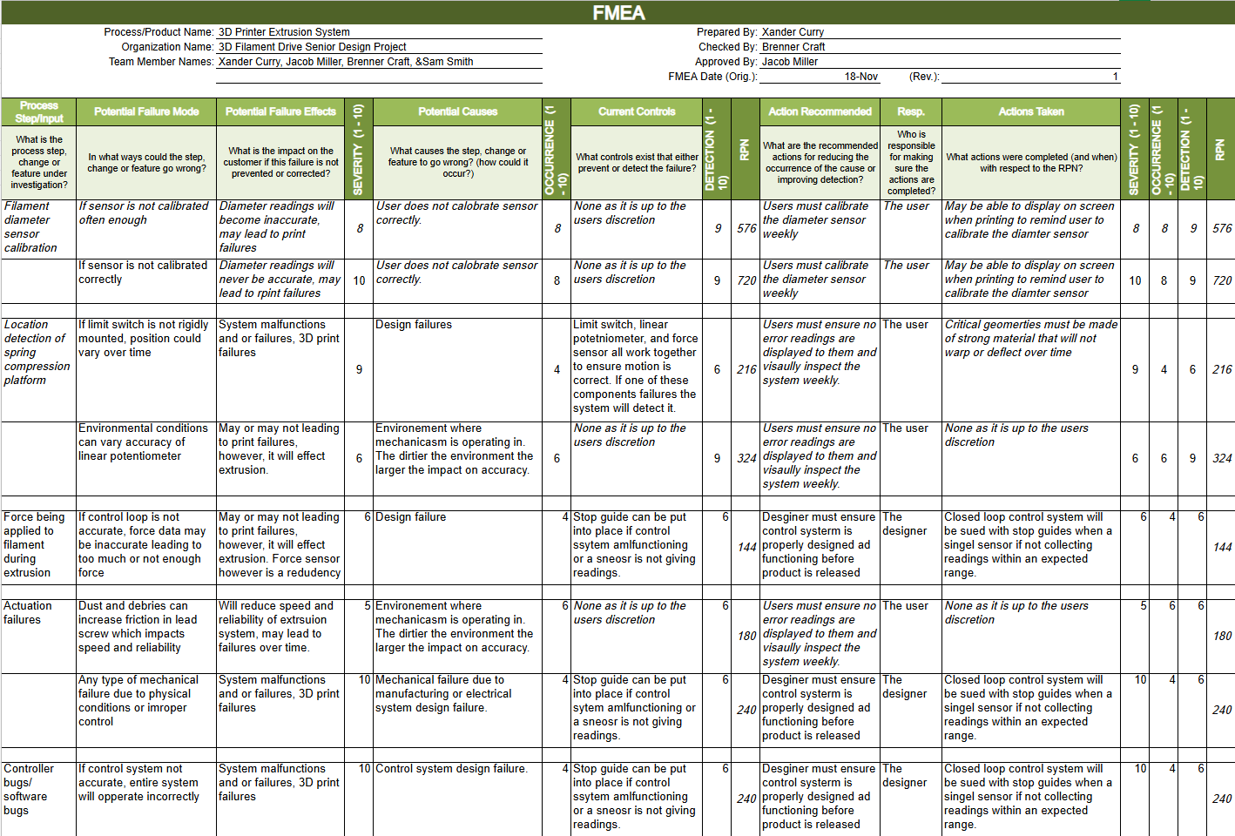

# Design Evaluation

The following section evaluates the chosen design against the specifications laid out previously in the report. Each performance specification is individually evaluated and compared to other potential solutions. Additionally, an analysis of the likelihood that the chosen specification will succeed can be found at the end of this section.

## Predicted Performance

The following subsections examine the design decisions that were made to satisfy each performance specification.

### Precision

To achieve a design with precision it was first necessary to determine components which have the greatest impact on how precise the system will be. One of these components is the actuator as it is responsible for making on the fly adjustments to increase or decrease the pressure on the filament. This general morphology can be seen in figure 5 to the right. Ultimately a linear actuation system using a lead screw and a platform was selected as it scored the highest in the actuation decision matrix, seen in table 2.

Figure 5: Actuation Movement

The latest prototype takes advantage of a pre-made linear rail. By selecting a pre-made linear rail, tolerance and functionality can be ensured over a custom-made rail system. The initial custom-made design, seen below in figure 6, would have primarily been made of PLA and PETG resulting in dimensional inaccuracies and high coefficients of friction. With the pre-made linear rail being precision machined out of stainless steel and aluminum it is far more likely to have higher precision.

|  |  |
| --- | --- |
| Diagram of a mechanical device with text and blue writing  Description automatically generated  Figure 6: Stepper Motor & Lead Screw | A black metal rod with a silver metal ball bearing  Description automatically generated with medium confidence  Figure 7: Pre-Made Linear Rail [4] |

This system will also take advantage of multiple sensors including the hall-effect sensor for determining filament diameter, a limit switch and a linear potentiometer to determine the exact position of the rail platform, and strain gauges mounted on the pressure arm to validate that the correct amount of force is being applied to filament. The use of multiple sensors was decided after they all scored highly in the sensor decision matrix, seen in table 4. With the advent of multiple sensors, this system can now have 2 redundant PID loops for control, which further improves precision, and also was preferred seen in the control system decision matrix, seen in table 5.

### Easy Assembly

In order to achieve a design with an easy assembly, the number of parts was minimized, and the electronics and control system are to be connected directly to the existing 3D printer’s main board. Initially the design called for a spring mechanism, seen in figure 6, to act as a damper and account for small variations in filament. However, this mechanism increased design complexity and added to the number of total components needed for the final assembly. Thus, it was removed from the system and replaced with a single component, being the rigid pressure arm seen in red in figure 8.

|  |  |
| --- | --- |
| A red machine with blue and red parts  AI-generated content may be incorrect.  Figure 8: Initial Cad Design | Diagram of a mechanical device with text and blue writing  Description automatically generated  Repeat of Figure 6 |

The decision to connect all electronics to the 3D printer’s power supply came from its high priority in the power system decision matrix, seen in table 5. This method does not require an external power supply, which would increase the total number of parts.

### Fast Response Time

In order to achieve a design with fast response times, the proper actuation system needed to be selected. Seen in the actuation decision matrix, table 2, the linear lead screw design scored the highest. This is based off their common use in CNC machines which are known for fast response times.

To further increase response time, the initial design was altered to have a more direct path to compressing filament. In a similar fashion to reducing components to improve ease of assembly, the number of components involved in compressing the filament was also reduced to ensure immediate response times. The spring mechanism, seen in figure 6, could result in a slight delay in the exact pressure being exerted on the filament, thus it was removed. This system will also feature an Arduino Nano. This microcomputer has a clock speed of 16 MHz. This enhanced processing speed enables the system to handle data more quickly than the filament diameter sensor can collect, ensuring rapid decision-making.

### Small Footprint

In order to achieve a design with a small footprint, component selection was critical. Despite the linear lead screw actuator scoring highly for a small footprint in the actuator decision matrix, seen in table 3, it was discovered that typical lead screws were 100 mm in length. To reduce footprint, the decision was made to use a smaller stepper motor which had a 50 mm lead screw. With this smaller rail system, the overall footprint was drastically reduced.

To further decrease the designs footprint, the sensor selection was changed. The initial design called for a load-cell to ensure that constant pressure would be applied to filament. However, after further prototyping it was determined that this sensor would increase the overall footprint and was replaced with a strain gauge. This force sensor system would have the same functionality as the original design but greatly reduce overall footprint. Another design decision to reduce footprint was to connect electronics directly to the existing 3D printer’s main board. This was based on the power system decision matrix, seen in table 5, as an option like an external power supply would increase the overall footprint.

### Lightweight

In order to achieve a lightweight design, a similar approach to reducing footprint size was taken. With a 50 mm linear rail compared to a 100 mm linear rod, the design was able to reduce weight by 107 grams. This may seem insignificant, however, considering that the total weight of the design with the 50mm rail is 620.46 grams, this is equivalent to a 15% weight reduction. To further decrease the designs’ weight, the sensor selection was changed as mentioned in the previous section. With the use of a limit switch and linear potentiometer the overall footprint was reduced, which in turn reduced overall weight. By applying the same reasoning that a smaller footprint results in reduced weight, sourcing power directly from the main board, rather than relying on an external power supply, further reduces the system's overall weight. This decision was also informed by the power system decision matrix, as outlined in Table 5.

To reduce weight even further, the mounting bracket and filament pressure arm are to be made of PETG, which when compared to a material like aluminum that is commonly used in manufacturing, is extremely lightweight while still having the strength required for this application.

### Maximize Lifespan

In order to maximize lifespan in the design, redundancies were included in the positioning sensor system. Both a linear potentiometer and a limit switch will be included in the positioning system to reduce the likelihood of mechanism failures. This position system is then further validated from the force detection system which uses 2 strain gauges. Having multiple set datums and constantly checking the position and force greatly drops the chances of a collision or excessive strain on components during actuation. These decisions were informed by both the sensor and control system decision matrices, seen in table 4 and table 3 respectively.

Other design decisions that maximize lifespan include the used of the linear lead screw. In this latest iteration a pre-made linear rail system is used, which is made of stainless steel and aluminum. With the actuation system experiencing the most movement, these robust materials will allow the system to last longer compared to the initial designs 3D filament-based rail system.

## Probability of Success

The following performance specifications were all taken into consideration for designing the final product. The product’s success depends upon each one and research and discussion was put into each category.

### Precision

The selected design was chosen because the lead screw will allow for high precision, compared to a linear actuator that simply presses on the gears of the print head, the thread angle of the screw will allow for minute adjustments, increasing precision and overall reliability. An important consideration for this device is the force that is needed to properly hold the filament. The following are the torque and factor of safety calculations for the Nema 11 Stepper.

$$Max holding torque \left(T\right)=F_{max}*\frac{\frac{L}{1000}}{2πe}=\left(31.14N\right)*\frac{\frac{1mm}{1000}}{2π\left(0.2\right)}=0.024 N*m$$

$$FoS=\frac{Torque}{Max Holding Torque}=\frac{0.07 N*m}{0.024 N*m}=2.8$$

The calculations yield a factor of safety of nearly 3, which is acceptable for this project. The figure below provides the numerical data for the variation in filament diameter for five samples of PETG filament. This data was collected and processed by Dr. Prawel’s research group and was supplied to the design team as background information.

Figure 9: PETG Spool Diameter Readings

To ensure this actuation system would be capable of the required precision, a target precision must be specified. In the figure above it can be seen that in a spool of PETG, a common filament type, diameter values range from 1.65mm to 1.85mm and the average diameter reading is around 1.75mm. It can also be seen that the interquartile ranges are typically around 0.025mm. This means that the most common variation in filament diameter is 0.025mm, however variations of 0.10mm should also be expected.

From this, it can be deduced that the pressure arm must be capable of 0.025mm – 0.10mm linear adjustments. Looking at the specifications of the linear rail system with a 1mm pitch of the lead screw, and a step angle of 1.8°, without micro stepping, the smallest linear movement is 0.005mm. With this being smaller, or more precise, than the requirement the precision needed will be achievable.

### Easy Assembly

The product is designed to be easily assembled by any at home user with a mid-level 3D printer such as an Ender 3. The entire BOM is easily found and bought online, and the housing is able to be 3D printed at home. Additionally, the power required will be able to be drawn straight from the printer’s board and require no additional power source. There will be a low part count of 47 parts for the customer to buy or print, mostly fasteners.

### Fast Response Time

The first of the specifications is precision. Stepper motors such as the Nema 11 that was chosen have a response time within milliseconds. This is vital to the product because the filament dimensions can change quickly and will require quick, minute adjustments. Through research it was determined that the stepper motor has quicker response time than common linear actuators. To ensure this actuation system would have a fast enough response time, the required response time must be determined.

It should be noted that the following values are based off the CURA slicer’s preset values for printing with a 0.4 mm nozzle. Typical print speeds, the speed that the print head is moving in the x and y planes, range between 40-100 mm/s. These print speeds corelate to extrusion rates, or volume of material traveling to the build surface, of 3.84-9.60 mm³/s. To convert this to the linear speed of filament traveling through the system, the extrusion rate will be divided by the cross-sectional area of filament which yields the following results:

* At a print speed of 40 mm/s, the linear speed of filament is 1.6 mm/s
* At a print speed of 100 mm/s, the linear speed of filament is 4.0 mm/s

With the maximum speed of the linear rail system specified as 40mm/s under a theoretical load of 3 kg, this actuation system will have a fast enough response time.

### Small Footprint

As seen in the figure below, the final prototype size is 173x87x142 mm (with filament sensor). In the initial prototype which had a cantilever design, maximum volume of 70 x 70 x 180 mm is possible before there is interference with surrounding components. However, after further prototyping and changing the orientation of the device, there were now no size constraints which allowed for a slight increase in overall size for the benefit of extra supports. Considering this, this latest prototype still keeps the footprint as reduced as possible while allowing for more robustness.

Figure 10: ISO Drawing with Dimensions

### Lightweight

The final prototype has a total added weight of about 620 grams. Using data from Ulti Maker, the flexural modulus of PETG is 2.05 GPa [5]. This is the value for a material’s stiffness in a bending scenario, which can be applied to this project’s cantilevered design. With a mass of .62 kg the prototype creates a load of 6.08 Newtons putting bending stress on the beam. The cross-sectional area of the linear rail beam is 363.5 mm^2 so taking the applied load and dividing it by this area yields a bending stress of .017 kPa. Therefore, the designed mechanism housing is lightweight and very rigid for the desired application.

### Maximize Lifespan

To maximize the lifespan of the filament drive, it was designed to make maintenance as convenient as possible. There is complete access to the linear rail mechanism for cleaning and observation to minimize the possibility for clogs/jams or possible collisions. Additionally, the redundant position sensors and task space created for this device make it virtually impossible for a catastrophic collision to occur during printing. Finally, after realizing that the initial cantilever design might lead to vibrations at the print head, rotating it 90 degrees and connecting it to the gantry bar provided more support to the extruder while lowering the effects of vibrations at the nozzle.

# Results & Test Procedure

To verify the functionality of this device a test would need to be designed which tracks the force on filament in correlation to filament diameter.

### Objective

The purpose of this device is to maintain constant force on filaments during the extrusion process. To verify this functionality, force applied to the filament during extrusion must be tracked alongside filament diameter to determine whether force remains consistent despite diameter variations. Two sets of tests are conducted using the same setup:

* Static Test: The pressure arm is fixed in place, maintaining contact with the filament but not adjusting based on filament diameter
* Dynamic Test: The actuation system is activated, enabling adjustment of the pressure arm based on real-time filament diameter and force readings from the load cell

### Environment

A test bench has been designed to monitor both the force applied to the filament and the filament diameter.

* The control system is programmed in Python
* Data from the Hall-effect sensor (filament diameter) and load cell (force) is output through the serial monitor and later exported to a .csv file

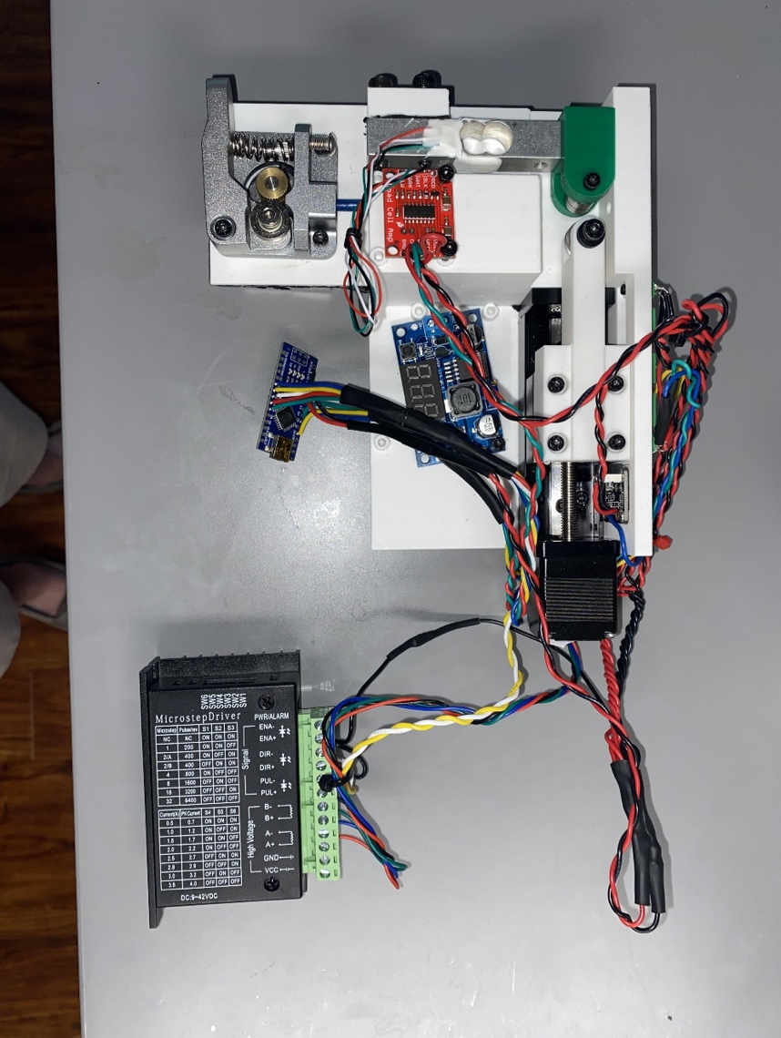

Figure 11: Test Bench Configuration

### Test Steps

1. Preload the filament through the diameter sensor and secure it using a standard extruder.
2. For the dynamic test, set a target force (e.g., 10 Newtons) that represents the desired constant force during extrusion.
3. For the static test, no target force is specified.
4. Start data collection by executing the control script and monitoring outputs via the serial monitor.
5. Once diameter and force readings appear in the serial monitor, start the extruder to continuously feed filament through the system.
6. During the dynamic test, the actuation system adjusts the pressure arm based on changing filament diameter and force feedback.
7. Continue extrusion for 10 minutes to collect sufficient force and diameter data.
8. After the test duration, stop the device and export the collected data as a .csv file.
9. Use RStudio or other software to visualize the data. Generate plots of Force vs. Sample and Diameter vs. Sample for both static and dynamic test scenarios.
10. Create a force distribution curve to compare the most frequently observed force values across both test conditions.
11. Use visualized data for further analysis and performance evaluation.

### Expected Results

Static Test:

Significant fluctuations in the force applied to filament are expected. No specific range is defined due to the exploratory nature of the test.

Dynamic Test

Smaller fluctuations in applied force are expected, with greater consistency maintained despite changes in filament diameter.

### Actual Results

Figure 12: Static Force Test Data Figure 13: Dynamic Force Test Data

Figure 14: Force Distribution Comparison

### Pass/ Fail Criteria

The test is considered successful if there is a measurable improvement in force consistency during the dynamic test compared to the static test. Specifically, the dynamic test should demonstrate a more stable force profile throughout the extrusion process, indicating effective compensation for changes in filament diameter.

### Comments

Figure 13 shows a sharper distribution of force values centered around the target force of 10 Newtons during the dynamic test, indicating improved force regulation. Additionally, Figure 12 illustrates a significantly more consistent range of force values during the dynamic test despite variations in filament diameter, further supporting the effectiveness of the control system.

# Future Work

Due to the time constraints of this project, a fully complete product was not created. The progress made throughout the year did meet or exceed the expectations of the advisors and sponsors, but there are still areas that could be studied further if more time allowed. The most important refinement for this project would be a more in-depth study of the impact on print quality. While it was outside of the scope of this project, it would be interesting to study the effect that this device has on layer adhesion and other print properties. Simple dimension and visual analysis were completed to compare prints with and without this device and no noticeable differences were observed. Further work may also include integration with some of the other work that the BERL is working on. An additional point of interest would be to study the volumetric flow entering the hot end by measuring the diameter of the filament in two dimensions.

In terms of the prototype that was developed in this project, more testing could help to ensure lifespan and verification that the results found are repeatable. Additionally, sourcing or fabrication of a smaller linear rail would help to reduce footprint and save weight. Additional work could also be done to adapt this project to other MEX 3D printers as many of the extrusion systems vary slightly from one another. While the is still work that could be done with this project, the progress of the work completed thus far can be considered a great success.

# Project Plan

The following sections provide the comprehensive plan for the second semester of this project including the Spring 2025 semester schedule, a critical path flowchart, and budget.

## Schedule

A full Gantt chart of the semester schedule can be found in Appendix B. The Gantt chart depicts critical tasks start and end dates, anticipated man hours for completion, and assigned personnel for each task. The most important deadline was E-Days being held in the 13th week. A brief overview of the semester tasks can be seen in the following critical path flowchart that highlights the interdependencies of each task.

Figure 15: Schedule

The above represents the Critical Path Flowchart outlining the work completed in the second semester of the. Building off of the work completed in the first half of the project, the focus of this semester was to refine the prototype as well as validate the function of the device. A separate system was developed to measure the fore applied to the filament. This test setup took the same electronics used on the printer but removed the printer. The test system ensured that data could be collected that would ultimately validate the design.

The test set up provided additional information and helped to refine the design for another prototype. Vibration testing was done to ensure that the device did not negatively impact any print quality. Using all the information gathered up until that point, a final prototype was created and tested before ethe E-Days deadline.

Adherence to key time constraints was critical to the project's success, and the critical path flowchart seen in figure 12 was crucial for maintaining progress. All project resources were stored in Dr. Prawel’s lab, including the control systems, allowing for consistent and convenient access. The group maintained the same work schedule established during the fall semester, meeting after lectures on Tuesdays and Thursdays to assign and manage weekly tasks. The roles within the team—project coordinator, CAD designer, code/control system lead, and research and testing head—will remain unchanged.

## Budget

The prototype cost breakdown, seen below in figure 13, shows the total cost of $122.57 broken into the following sections: Mechanical & Structural System, Control System, and Diameter Sensor System. The Mechanical & Structural System slice includes the cost of PLA, PETG, mounting hardware, and the stepper motor linear rail system for actuation. The Control System slice includes the costs of microcontrollers, stepper drivers, and sensors used for position detection. The Diameter Sensor System slice includes the cost of all components required to construct the filament diameter sensor developed by Thomas Slanderer.

Figure 16: 3D Filament Drive Prototype Cost Breakdown

Figure 17: Current Budget Breakdown

The budget breakdown, seen above in figure 14, shows all funds spent to date split between prototyping component costs and research equipment, totaling $2659.29. The total prototyping cost is higher than the individual prototype cost, seen in figure 6, as this figure shows total cost instead of the cost per unit. The Research & Development slice includes the cost of the Ender 3 Pro 3D printer, the Prusa MK3S+ 3D printer, as well as the cost for filament and filament storage devices.

# Conclusion

This project addresses critical challenges in melt extrusion, additive manufacturing, specifically in mid-level Fused Deposition Modeling (FDM) 3D printers where inconsistent filament diameters and extrusion rates significantly impact print quality, strength, and sustainability. By leveraging proven correlations between filament diameter and print quality, the proposed system focuses on real-time compensation to maintain consistent extrusion rates, reducing defects and minimizing material waste. This approach overcomes limitations of existing solutions, such as cost-prohibitive sensors and post-processing defect detection, while enhancing print quality, part strength, and energy efficiency.

Building upon research conducted by Dr. Prawel’s group at Colorado State University, the project works to increase the consistency of force in mid-level 3D printing systems. The resulting system has the potential to establish a new standard for reliability in additive manufacturing, aligning with industry sustainability goals and providing a scalable solution for improving the performance of cost-sensitive 3D printing platforms.

However, design risks associated with control system errors must be addressed to ensure success. These risks require reevaluation of system design and implementation of rigorous testing protocols, including integration trials in controlled environments, verifying signal integrity, and ensuring seamless communication between subsystems. By mitigating these challenges, the project provides a robust pathway to improving additive manufacturing quality while contributing to sustainability objectives.

# Appendix A: House of Quality

# Appendix B: Gantt Chart

# Appendix C: Design Matrices

Table 6: Control System Design Matrix

Table 7: Sensor System Design Matrix

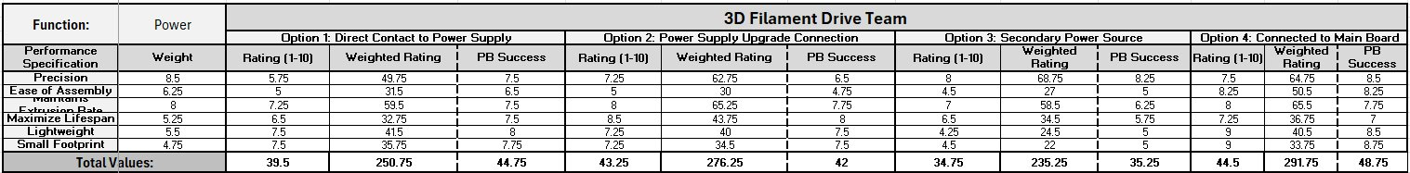

Table 8: Power System Design Matrix

# Appendix D: Initial Design Ideas

|  |  |
| --- | --- |
| Diagram of a mechanical device with blue writing  Description automatically generated  Figure 18: Design 1: Servo & Linkage | Diagram of a mechanical mechanism with text and blue writing  Description automatically generated  Figure 19: Design 2: Linear Actuator |
| A diagram of a mechanical device  Description automatically generated  Figure 20: Design 3: Stepper Motor & Arm | Diagram of a mechanical device with text and blue writing  Description automatically generated  Figure 21: Design 4: Stepper Motor & Lead Screw |

# Appendix E: Initial Proof of Concept CAD

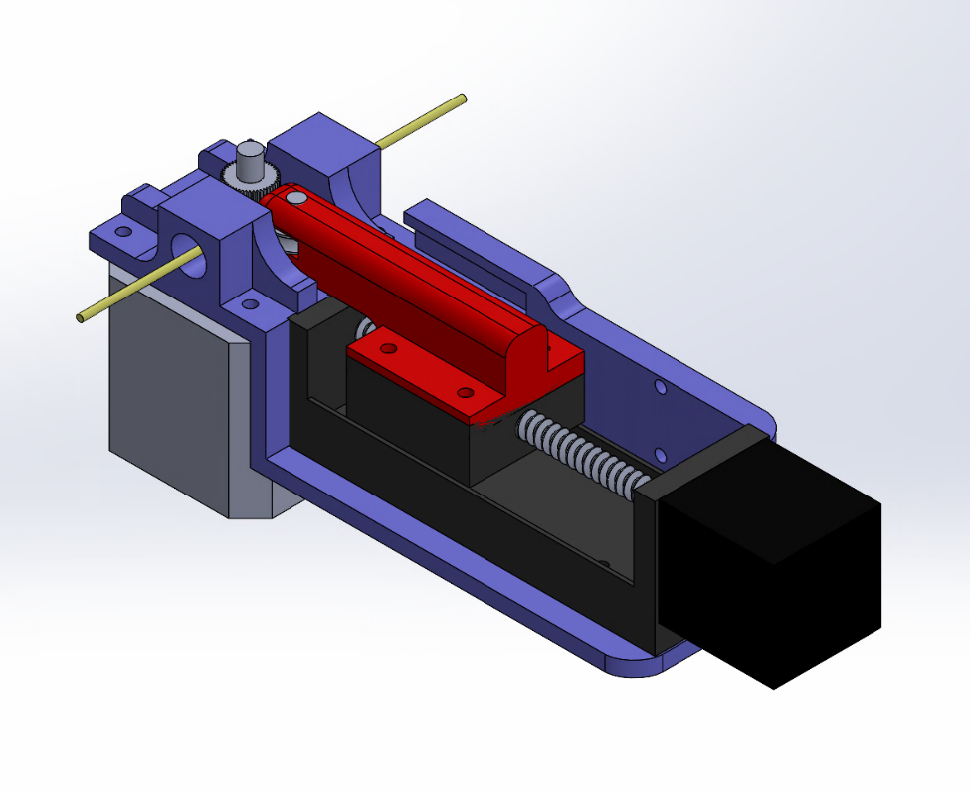

Figure 22: First Prototype Isometric View

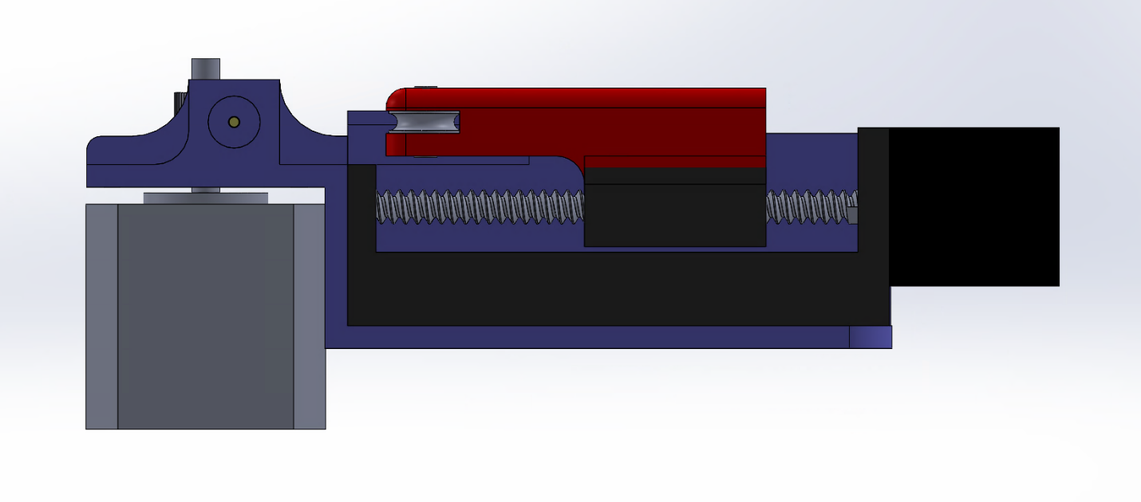

Figure 23: First Prototype Side View

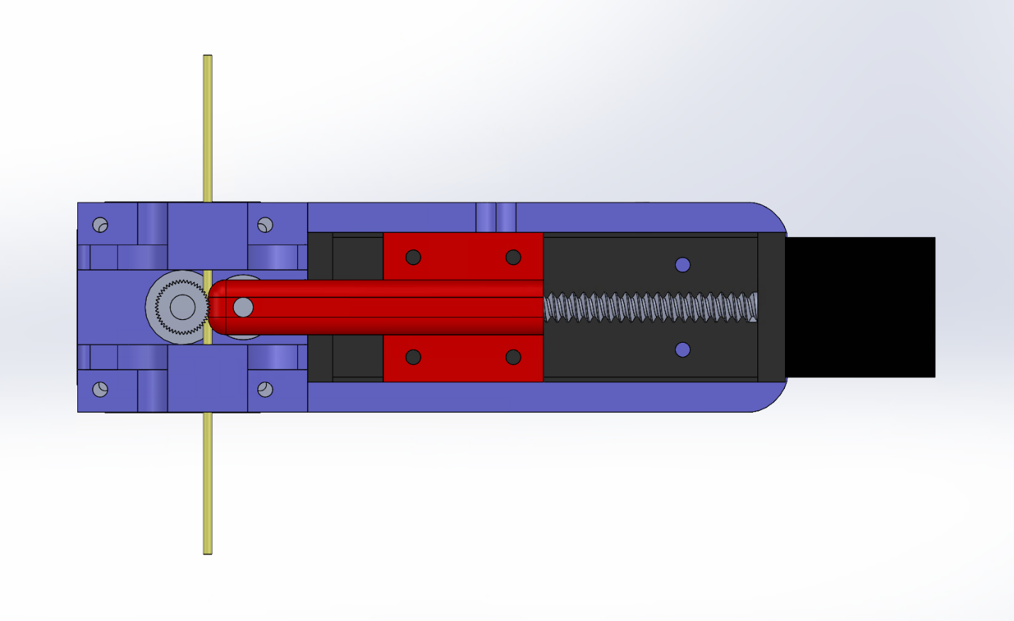

Figure 24: First Prototype Top View

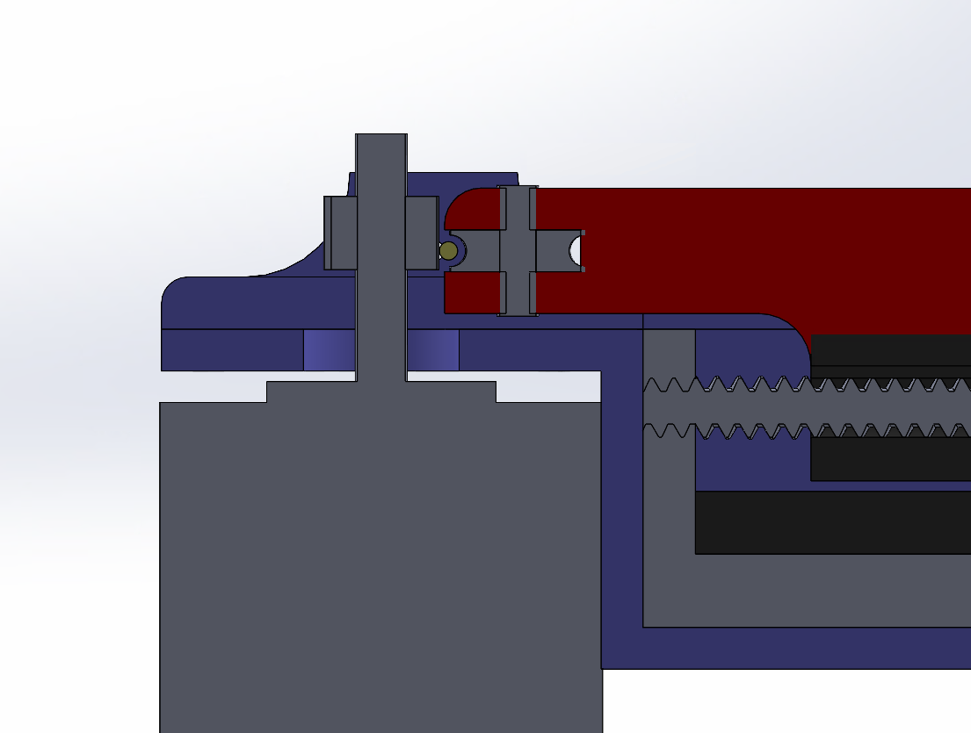

Figure 25: First Prototype Detail View

# Appendix F: Final Prototype CAD Models

Figure 26: Final Prototype Front View

Figure 27: Final Prototype Top View

Figure 28:Final Prototype Isometric View

Figure 29: Final Prototype Front View

Figure 30: Final Prototype Exploded View

Figure 31: Pressure Arm Drawing

Figure 32: Mounting Bracket Drawing

Figure 33: Electronics Housing Drawing 1

Figure 34: Electronics Housing Drawing 2

# 

# Sources

[1] Boulaala, M., Elmessaoudi, D., Buj, I., & el Mesbahi, A. (2020). Towards design of mechanical part and electronic control of multi-material/multicolor fused deposition modeling 3D printing. The International Journal of Advanced Manufacturing Technology. Retrieved from <https://www.researchgate.net/figure/Basic-diagram-of-FDM-3D-printer-extruder-a-Direct-extruder-b-Bowden-extruder_fig1_343539037>[ResearchGate+1ResearchGate+1](https://www.researchgate.net/figure/Basic-diagram-of-FDM-3D-printer-extruder-a-Direct-extruder-b-Bowden-extruder_fig1_343539037?utm_source=chatgpt.com)

[2] A.-I. Portoacă, A. Diniță, M. Tănase, A. Săvulescu, E.-E. Sirbu, C. Călin, and G. Brănoiu, "Analyzing Sustainable 3D Printing Processes: Mechanical, Thermal, and Crystallographic Insights," *Polymers*, vol. 16, no. 10, p. 1364, 2024. [Online]. Available: <https://doi.org/10.3390/polym16101364>

[3] T. T. Wohlers *et al.*, "Wohlers report: 3D printing and additive manufacturing global state of the industry," *Additive Manufacturing Industry Report 2022*, Fort Collins, CO, USA: Wohlers Associates, 2022. [Online]. Available: https://wohlersassociates.com/2022report.htm

[4] TOAUTO. (n.d.). Linear Rail 50mm Length Travel Linear Stage Actuator with Square Linear Rails Mini Slide Table + NEMA 11 Stepper Motor for DIY CNC Router Milling Machine (50mm). Amazon. Retrieved May 9, 2025, from <https://www.amazon.com/Linear-Actuator-Stepper-Milling-Machine/dp/B07K7FWDZJ>

[5] "Method Series PETG," Ultimaker, Accessed: Dec. 04, 2024. [Online]. Available: <https://ultimaker.com/materials/method-series-petg/>

[6] "University Symbol," Colorado State University Brand, Accessed: Dec. 04, 2024. [Online]. Available: <https://brand.colostate.edu/symbol/>